**Lab 07**

**Objectives:**

This lab will enable students to:

* + Code using Behavioral level modeling
  + Implement FSM for sequence detector

**TASK:**

**Build an electronic combination lock with reset button, two number buttons (0 and 1), and an unlock output. The combination should be “01011”**

Description:

A combinational digital lock has three input buttons for Reset, entering a “0” and entering a “1” and output button UNLOCK and state which shows in which state the machine is currently in.

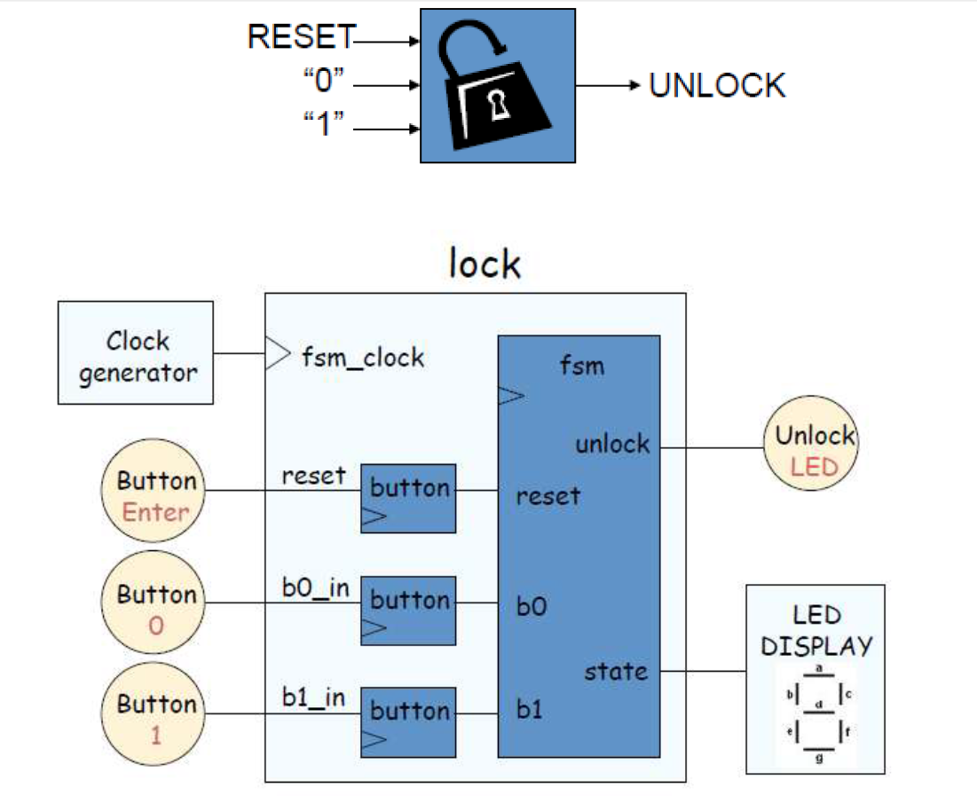

Fig: Block Diagram

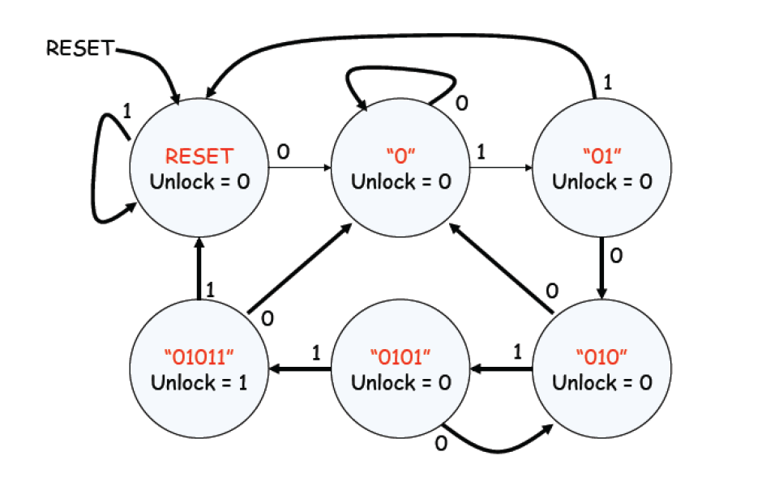

Fig2: State Transition Diagram